*Parth Chandgadhiya 300986134

Linux Assignment 2 – Laxmi Govinda

Answer 1: -
shell script to find the greatest and lowest of three numbers.
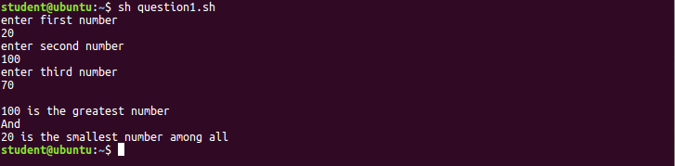
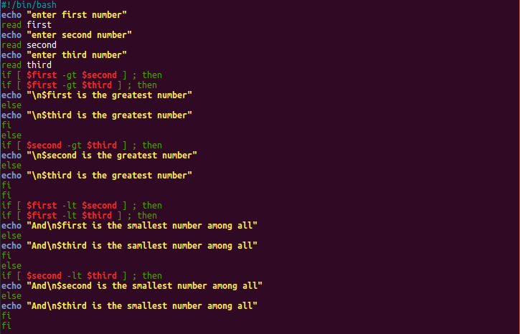

Answer 2: -
shell script to find the sum, reverse of a two-digit number, and find out which digit in reverse is greater than the other.
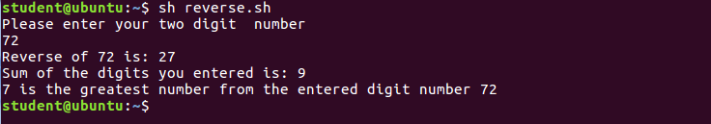
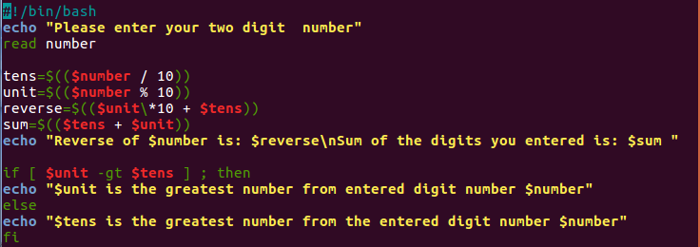
Additional: -
shell script to find the sum.
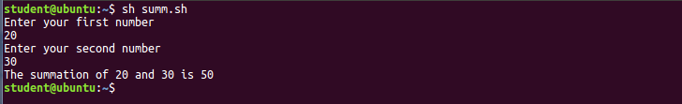
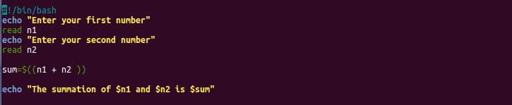
a shell script to find reverse of a two-digit number.
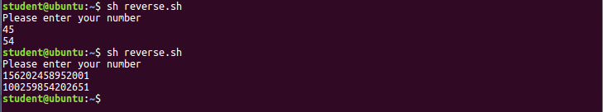
Or
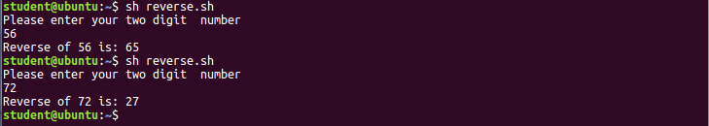
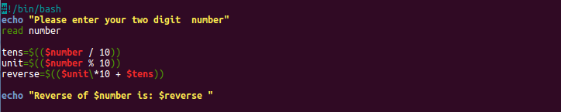

Answer 3: -
Shell script to display the list of Music albums or the Artist name. Based on the choice of selection
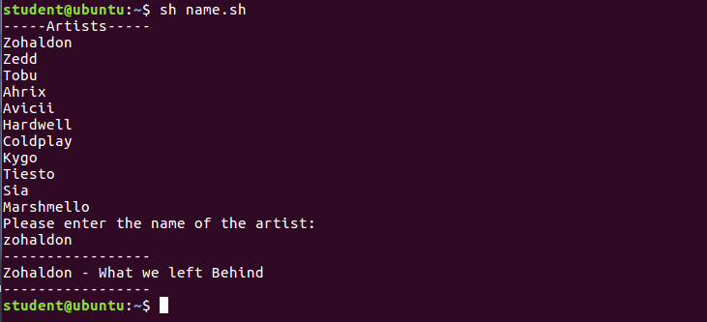
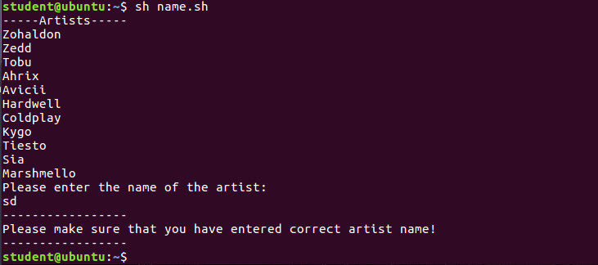
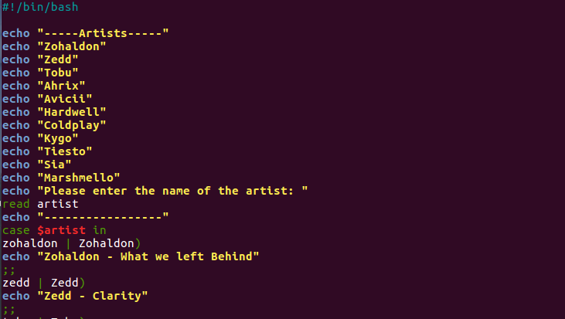
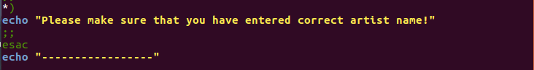

Answer 4: -
Write the shell script to input the electricity unit charge and calculate the total electricity bill.

Less than 50)
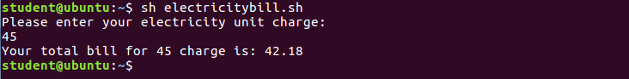
Between 50 to 150)
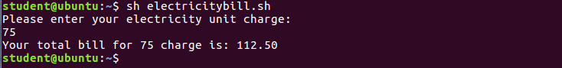
Between 150 to 250)
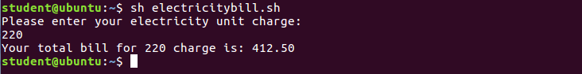
Greater than 250)
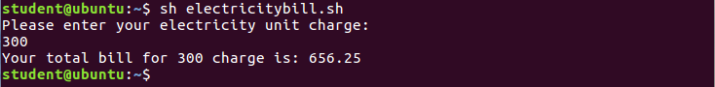

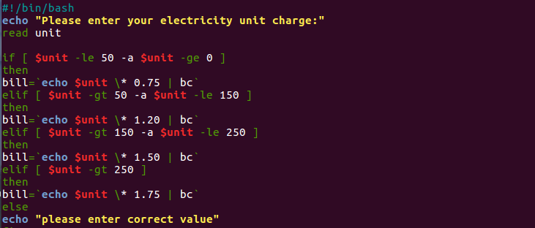
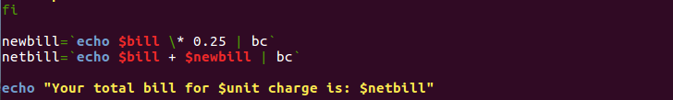

Answer 5: -
Write a shell script program to display in words the name of each month. Based upon the input number.
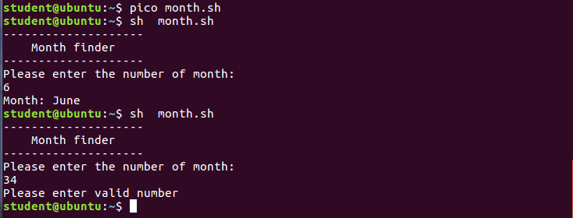
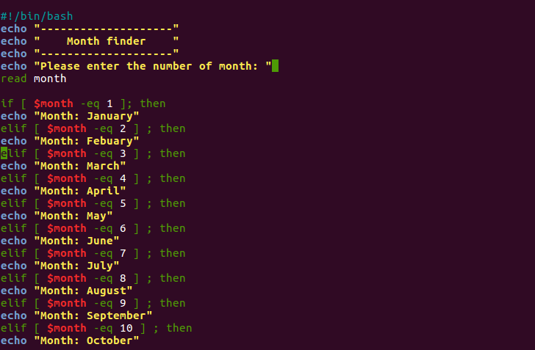
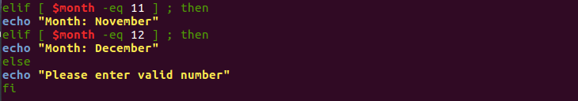

Answer 6: -
Write the program to calculate the “total amount” to be paid.
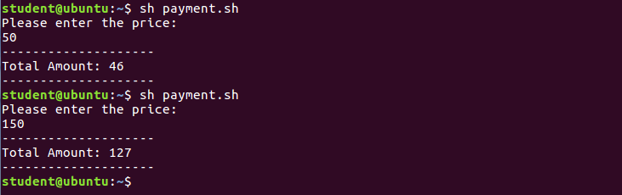

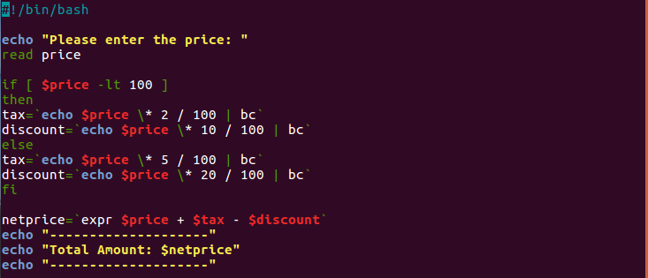

Answer 7: -
Write a shell script to develop an APP for the XYZ bank which has the proposal to offer loans to the customers
Amount greater than 5000)
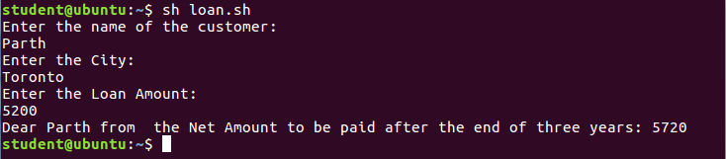
Between 4000 and 5000)
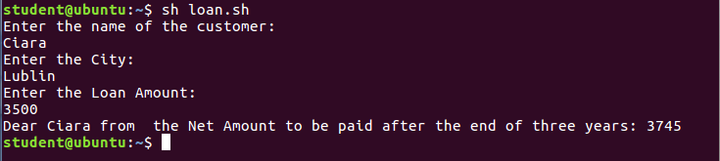
Between 3000 and 4000)
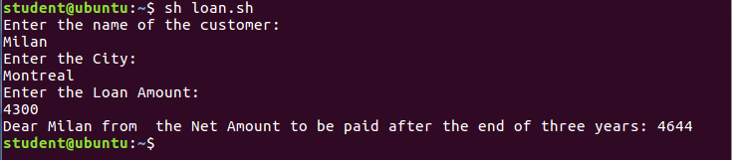
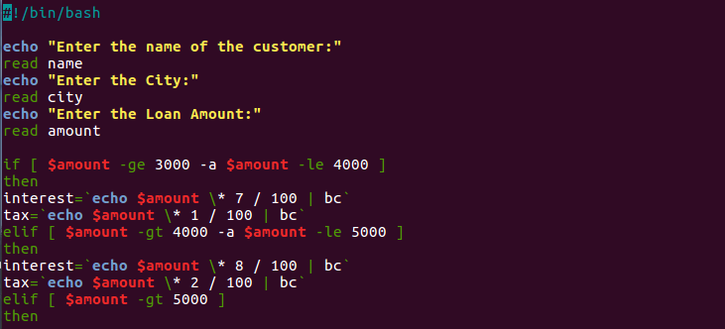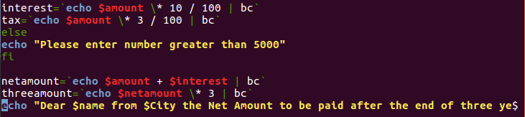

Answer 8: -
Write a shell script to develop an APP to calculate the net salary of an employee.
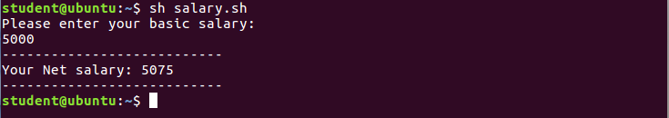

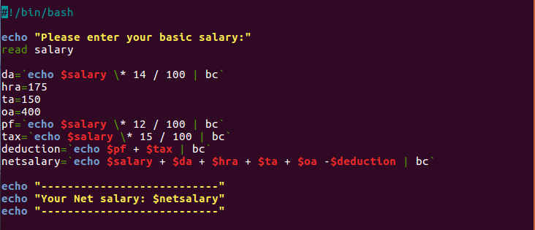

Answer 9: -
Write a shell script calculator program to take two inputs to perform the choice of operation on Addition, Subtraction, Multiplication, Division and Modulus.

1) Addition.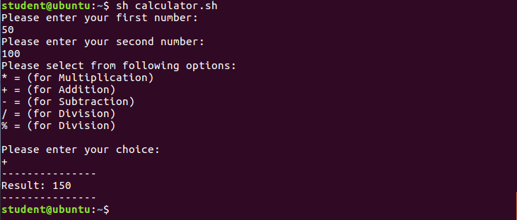
2) Subtraction
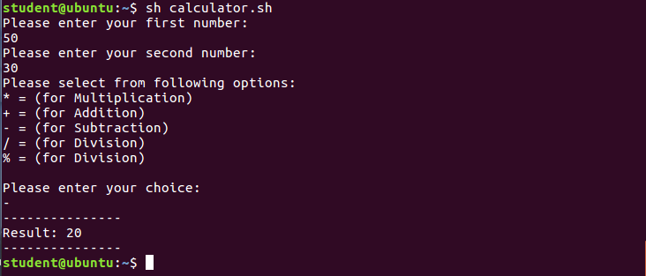
3) Multiplication
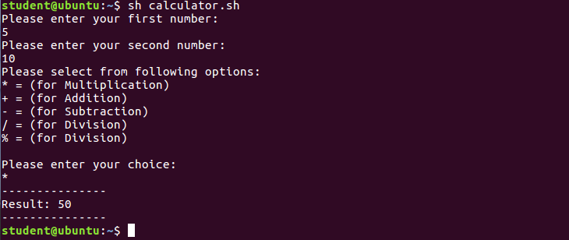
4) Division
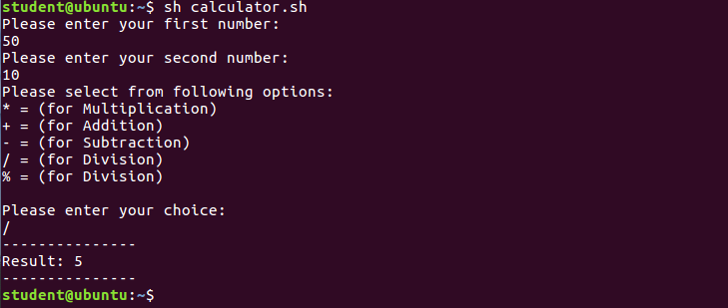
5) Modulus
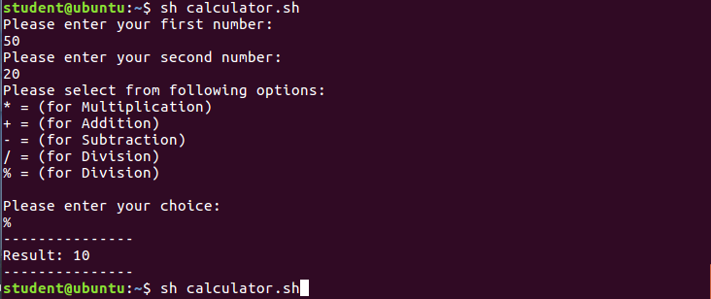
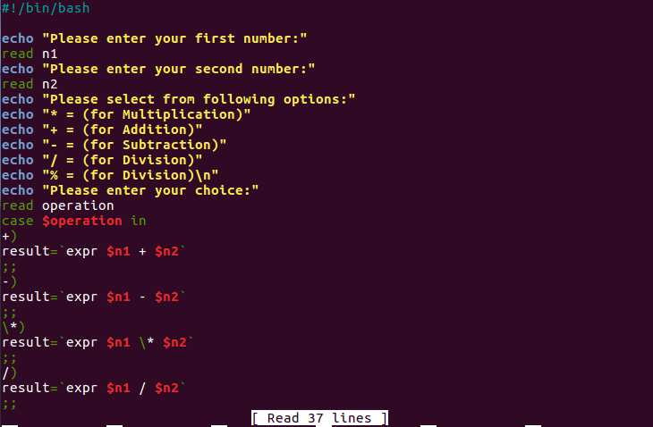
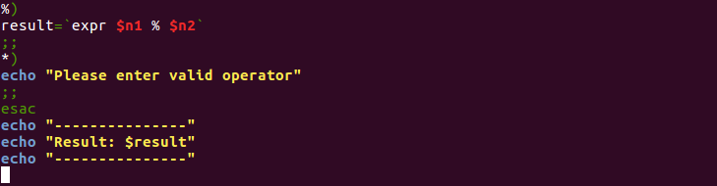

Answer 10: -
1) Yum:
- Yum is an interactive Repository manager tool. It automatically performs the system updating process and fetching out the appropriate packages for the operating system.
- Yum stands for “Yellowdog updater modifier” and is default package manager for some versions of the Linux like Red hat, Fedora etc.
- Some basic syntax for yum are:
  - “Yum install package file “- for installing the package.
  - “Yum remove package file” - for uninstalling the package.
  - “Yum update package file” – to update the current package.
  - “Yum search package file” – to search for the package.
  - “Yum info package file” – to get the info of the package.
  - “Yum list” – to list all the packages in yum database.
2) Rpm:
- Rpm stands for “Red hat package manager”
- Rpm allows the user with administrator rights to install, uninstall, update, verify, query, and manage the system software packages. it works only with the packages that are .rpm by format, with all of the information stored at “/var/lib/rpm”
- Its main syntax is “rpm {-i|--install} [install-options] PACKAGE_FILE”
- Following are diverse options that could be assign with rpm:
  - “-i” for installing the package
  - “-Q” To query a package.
  - “-e” To remove the package.
  - “-U” For upgrading the current package.
  - “-Vp” To verify the package.
  - “-R” List the capabilities on which the package is depended.
  - “-nodeps” To avoid the dependencies check.
3) du:
- du stands for “Disk Usage”.
- As the name suggests it estimates the usage of the disk with the directory as the default view.
- Main syntax “du [-options] [filename]” and some basic options are:
  - “-a” displays information for both files and directories
  - “-b” displays the information in bytes
  - “-c” creates a total at the end
  - “-h” displays the information in “human-readable” format
  - “-s” omits the size of subdirectories in the totals for directories
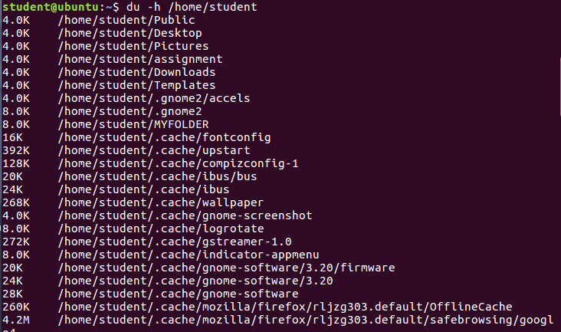

4) fstab:
- fstab stands for “file systems table”
- fstab is a system configuration file located at “/etc/fstab”
- fstab is used utilized to define disk partition, to list disk partitions, mount the devices such as CDROM, floppy and much more and it indicates how they needs to be initialized into the overall system's file system.
- Fstab has six fields in its syntax:
  - First field: corresponds the device name
  - Second field: mentions the mount for the device supposed to be mounted.
  - Third field: mentions the filesystem type
  - Fourth field: describes the mount options.
  - Fifth fields: mentions the option that need to be used by the dump program.
  - Sixth field: mention the fsck option
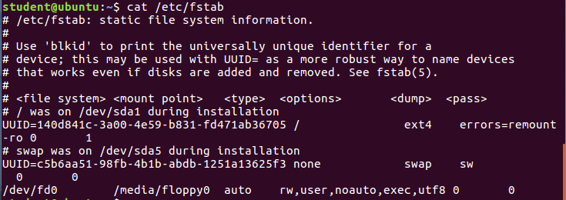

5) fsck:
- Fsck stands for “file system consistency check”
- Fsck is a tool for checking and repairing the Linux filesystem.
- Syntax for fsck is “fsck [-lsAVRTMNP] [-r [fd]] [-C [fd]] [-t fstype] [filesystem...] [--] [fs-specific-options]”
- Exit codes for fsck command are as follow:
  - 0 – No errors
  - 1 – filesystem error
  - 2 – system reboot required
  - 4 – filesystem error left uncorrected
  - 8 – operational error
  - 16 – syntax error
  - 32- fsck command cancelled by user request
  - 128 – shared- library error
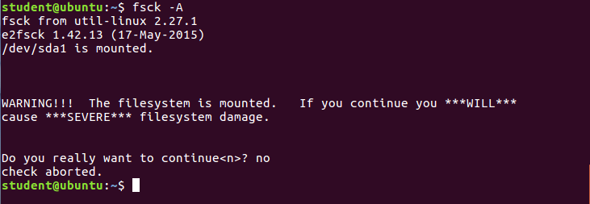
6) Mount / Unmount:
Mount: -
- Mount is a process through which we could make any filesystem available to the certain point in the Linux directory tree and could access it.
- Main syntax “mount [-t type device dir]” some basic options are:
  - “-h” displays help information.
  - “-v” displays the version information.
  - “[-l] [-t types]” shows all the mounted filesystem as a list.
  - “-a” mount all devices excluding the “no auto” defined options.
Unmount: -
- It is the reverse of the mount command.
- Unmount command removes the mentioned file from the file hierarchy to unmount any filesystem one needs to specify the directory where it was mounted.
- Main syntax “umount -a [-dflnrv] [-t fstype] [-O option...]” or “umount [-dflnrv] {directory|device}”
- some basic options that one could use are:
  - “-h” displays help information.
  - “-v” displays the version information.
  - “-A” to unmount all the targeted files.
7) Hostname:
- Hostname is used to show the DNS name of the system and to set its hostname or NIS domain name.
- Syntax hostname would print the name of the current host. The super-user can set the hostname by supplying an argument
- Main syntax for hostname is “hostname [-f] [-s | -d]”
- The syntax options for hostname are as follow:
  - “-f” domain information is printed with the name.
  - “-s” prints only name.
  - “-d” only prints the domain information

